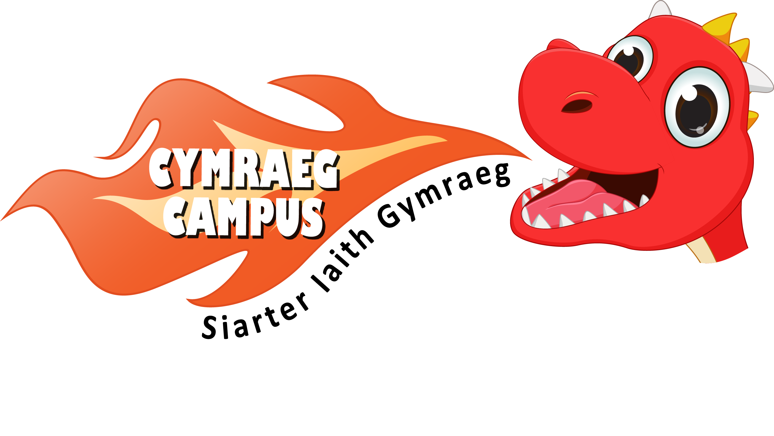
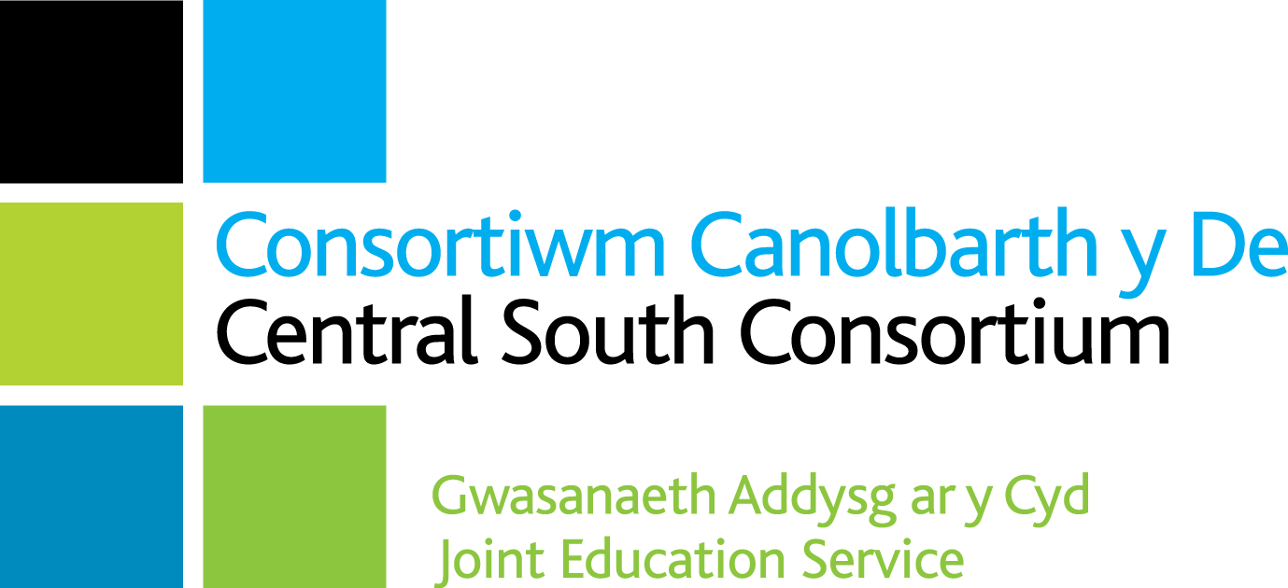
Adroddiad Siarter Iaith Cymraeg Campus
Siarter Iaith Cymraeg Campus Report

Ysgol / School: Ysgol Gynradd Sain Tathan
Gwobr / Award: Efydd

Targed /Target | Meysydd llwyddiannus /Areas of success | Taro’r targed/Target met?
Un - Sefydlu ethos Gymreig weledol  Visual Welsh ethos | Pupils were proud of the Welsh ethos in their school and an active Criw Cymraeg could identify prominently placed displays in and outside of classes. In the hall there are two displays, one highlighting the targets and progress, another showing weekly photographs of weekly Welsh winners.  ‘Helpwr Heddiw’ was used throughout the school and a bilingual approach to signage was used across the site. | Yes
Dau - Manteision dysgu’r Gymraeg  Advantages of Welsh | Criw Cymraeg could clearly explain why learning Welsh was important to them and their community.  Winning Croeso posters and the benefits and advantages of Welsh are displayed outside of classes. | Yes
Tri - Y defnydd o’r Gymraeg yn achlysurol o fewn yr ystafell ddosbarth Incidental Welsh in the classroom | On the learning walk, incidental Welsh was used and understood.  General marks and dates are used in Welsh by staff.  All pupils could respond to basic questions with great degree of confidence.  In Progression step one classes, snack time was happening using incidental Welsh. | Yes
Pedwar - Y defnydd o’r Gymraeg yn achlysurol y tu allan i’r ystafell ddosbarth Incidental Welsh outside the classroom | Cwestiwn yr wythnos was promoted by the Criw Cymraeg and teachers nominated their ‘Siaradwr yr Wythnos’ as a reward.  Reception and dinner staff are encouraged to use incidental Welsh. | Yes
Pump - Cymraeg yn y Gwasanaethau  Welsh Assemblies | Criw Cymraeg enjoy promoting Welsh during assemblies, giving rewards for Siaradwyr yr Wythnos and encouraging the use of Welsh stories and songs.  Welsh songs, including Yma o Hyd, Calon Lan, Aderyn Melyn and Sosban Fach, are clearly embedded from assemblies and events.  Criw Cymraeg said that they enjoy greeting people on entry to assembly and take great pride in leading lots of Welsh cultural events in their school such as the Eisteddfod. | Yes
Chwech - Apiau a gwefannau i fireinio’r dysgu a’r mwynhad  Welsh Apps and Websites | Pupils use a range of Welsh websites and apps.  iPads are utilised for Welsh tasks and accessing apps.  Welsh oracy activities are displayed via QR codes in books.  Criw Cymraeg have prepared posters about appropriate Welsh apps and websites, which are displayed in classes. | Yes
Saith - Gweithgareddau cyfoethogi  Enrichment activities | An annual school Eisteddfod is held with a range of competitions, including writing, drawing and singing and a beautiful chairing of the bard ceremony with attractive costumes and decor.  Criw Cymraeg has started assisting in organising celebrations for Cwmpan y Byd, Santes Dwynwen, Seren & Sbarc etc. and hold a range of events throughout the school year.  Pupils also experience a range of Welsh trips | Yes
Wyth - Datblygu darllen  Developing Reading | All classes have an appropriate range of reading resources.  Welsh books are clearly available in the school library and in each classroom. | Yes
Naw - Cymraeg ar draws y Cwricwlwm  Welsh across the curriculum | Purposeful Welsh phrases displayed where appropriate.  Welsh marking comments are used by staff along with Welsh stamps and stickers.  Bilingual opportunities are clear in lesson plans.  Welsh is used in aspects of some lessons. In addition, the date is written in Welsh in books. | Yes
Deg - Agwedd Gadarnhaol  Positive attitude to Welsh | Pupils and staff alike demonstrate a highly positive attitude to Welsh.  Members of the Criw Cymraeg obviously enjoy their role and are eager to continue and develop it further. | Yes

Sylwadau Cyffredinol / General Comments
- Diolch for fostering a passionate Criw Cymraeg who clearly have a great understanding of incidental Welsh and actively promote the language and culture of Wales! They are instrumental in implementing, developing, and monitoring Siarter Iaith Cymraeg Campus. This ensures a strong pupil voice throughout the process.
- Siarter Iaith Cymraeg Campus is driven by strong leadership from the Siarter Iaith Cymraeg Campus leader.
- Appropriate evidence has been collected for all ten targets digitally and there is very strong and attractive evidence clearly displayed and celebrated around the school.
- Whilst celebrating and taking pride in the school’s progress, leadership are eager to embed the good practice and continue to develop the Welsh ethos they have worked so hard to achieve. They intend working on the Silver award straight away! .
Llongyfarchiadau i bawb yn Ysgol Gynradd Sain Tathan, rydych chi’n llwyr haeddu gwobr efydd Siarter Iaith Cymraeg Campus.
Congratulations to everyone in St Athan’s Primary School, you richly deserve the Siarter Iaith Cymraeg Campus bronze award.

Prif Meysydd i’w Datblygu / Main Areas for Development
- The Criw Cymraeg to continue to monitor, encourage and eventually lead the way on Welsh development.
- Develop links with parents & the local community. The School has a rather unique community with a military presence, we look forward to seeing how the Criw Cymraeg can creatively impact upon this community with their Welsh.
- Develop links with a local Welsh or English medium school to work in partnership to develop Cymraeg

Dilyswyd gan/Verified by: Deb Durham

Dyddiad/Date: 12/03/2024

